**Section 7: Amazon S3:**

* + 1. **S3 Overview:**

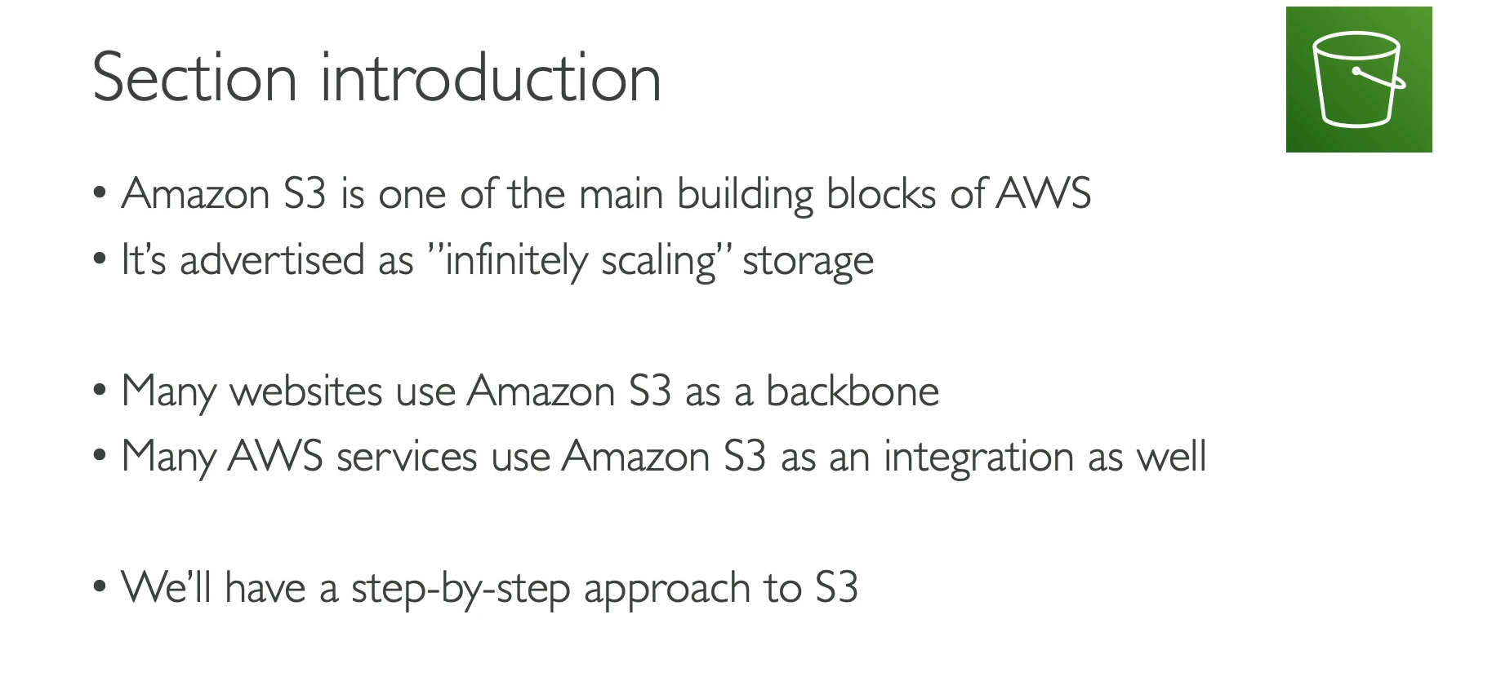

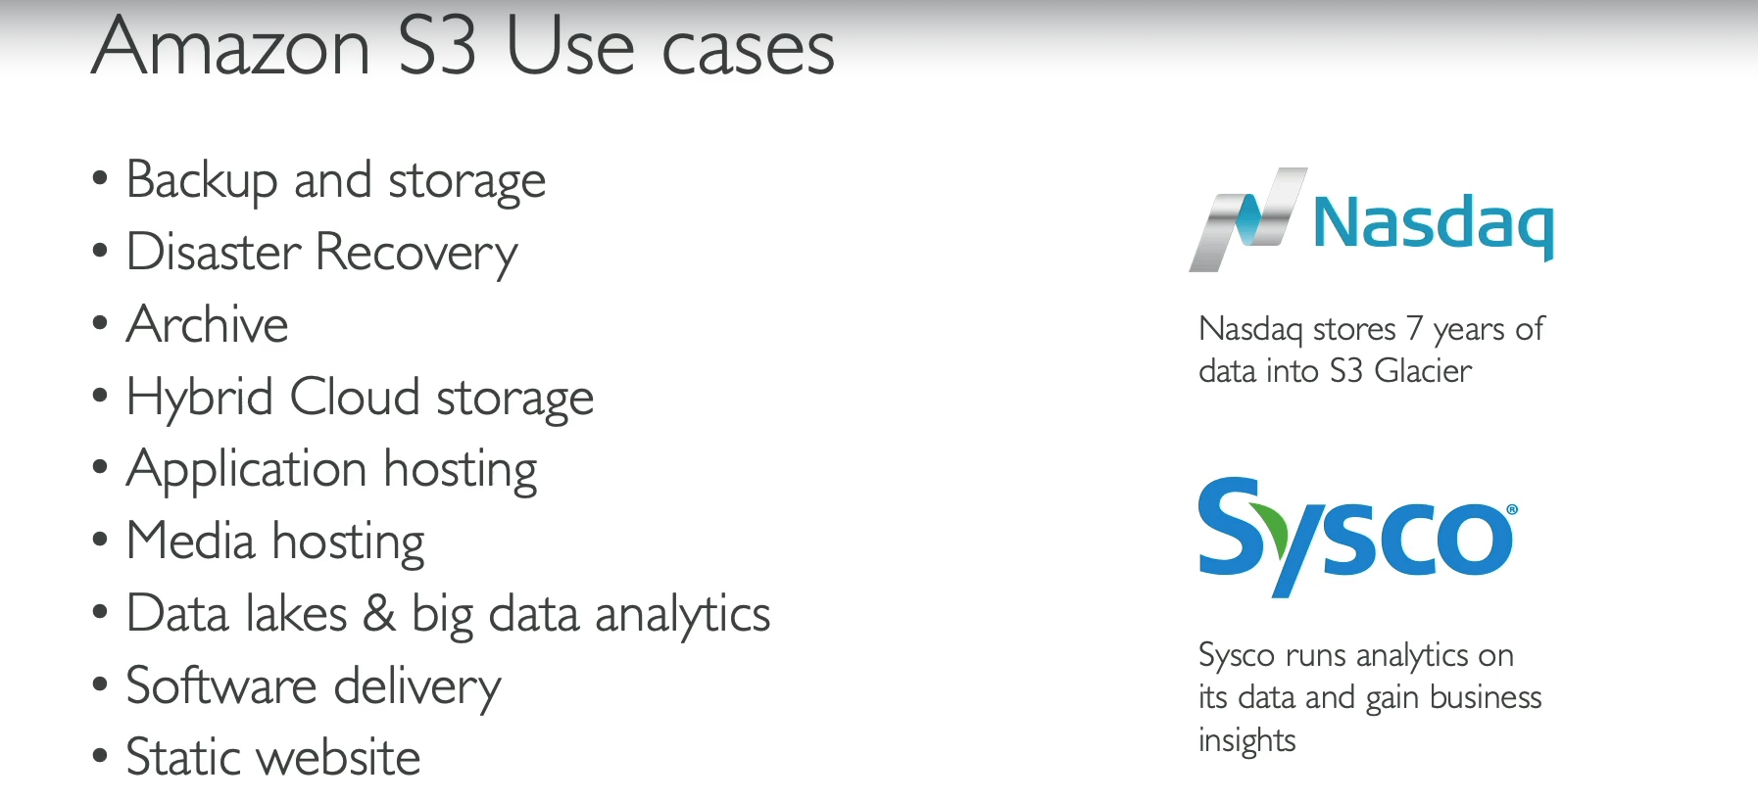

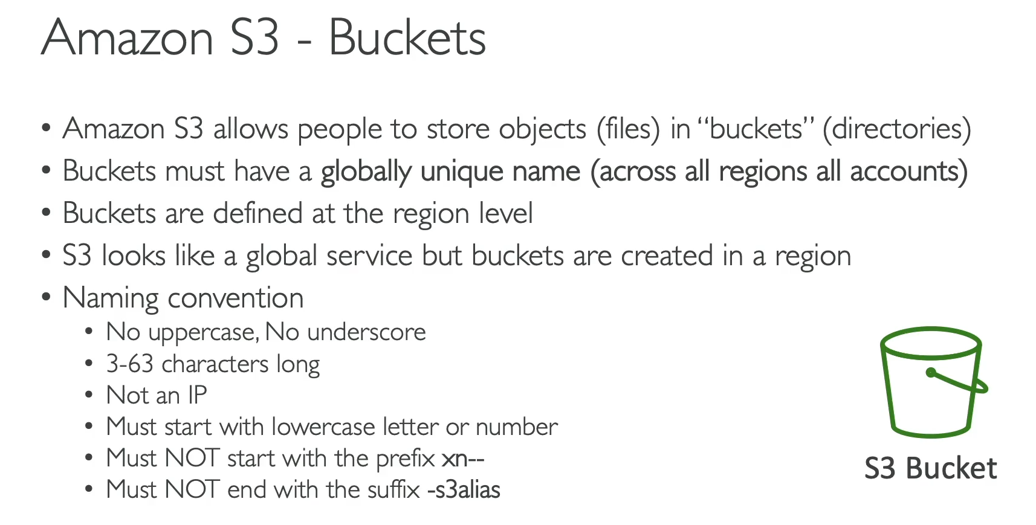

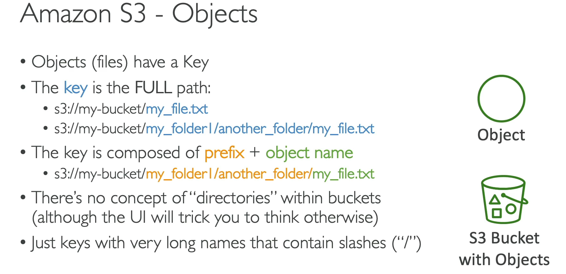

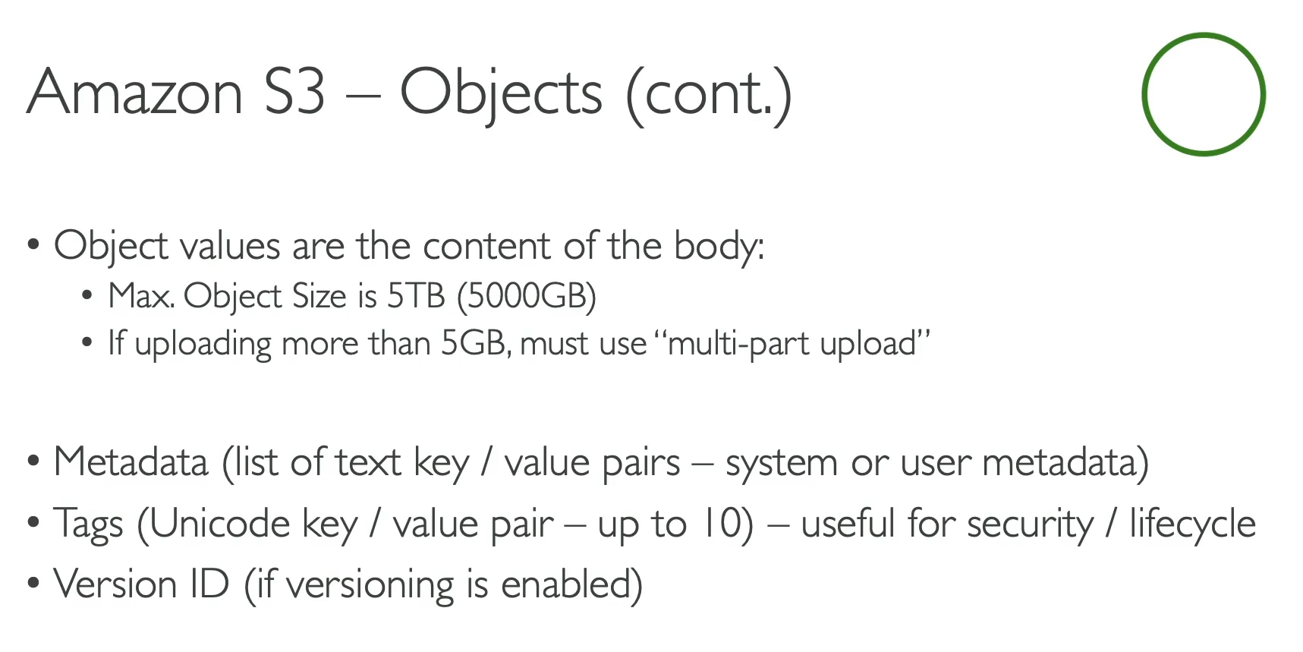

Amazon S3 (Simple Storage Service) is a core AWS service that provides scalable, object-based storage. It is often described as "infinitely scaling storage" and is a fundamental building block for many applications and other AWS services.

**Key Concepts**

* **Buckets:** S3 stores files, called **objects**, within containers called **buckets**.
* **Global Uniqueness:** Bucket names must be **globally unique** across all AWS accounts and all regions. This is a crucial point and a common misconception for beginners. Because bucket name must be unique globally. So, we thought that S3 is a global service, but it is wrong. Even though the name is unique, we must create the S3 bucket in a specific AWS region.
* **Regional:** Although the name is globally unique, an S3 bucket is **created in a specific AWS region**.
* **Objects and Keys:** An object is a file in S3, and its **key** is its full path within a bucket (e.g., myfolder/myfile.txt). S3 doesn't have a true directory structure; folders are just a way of visualizing keys with a common prefix.
* **Object Properties:** Objects can have a value (the file content itself), **metadata** (key-value pairs about the object), and **tags** (up to 10 user-defined key-value pairs useful for management).
* **Maximum Size:** The maximum size of a single object is **5 TB**. Files larger than 5 GB must be uploaded using a **multi-part upload** process.

**Use Cases**

S3 has a wide range of applications due to its versatility and scalability:

* **Backup & Storage:** Storing files, disk images, and other data for general storage or disaster recovery.
* **Archival:** Long-term, low-cost storage of data using services like S3 Glacier.
* **Hybrid Cloud Storage:** Extending on-premises storage into the cloud.
* **Static Website Hosting:** Serving static website content (HTML, CSS, JavaScript).
* **Media Hosting:** Storing and serving videos, images, and other media files.
* **Big Data Analytics:** Storing large datasets in a data lake for analysis.

**Bucket Naming Conventions**

To ensure global uniqueness, S3 bucket names must adhere to specific rules:

* Use only lowercase letters, numbers, and hyphens.
* Must be between 3 and 63 characters long.
* Cannot be formatted as an IP address.
* Must start with a lowercase letter or number.
  + 1. **S3 Bucket Hands On:**

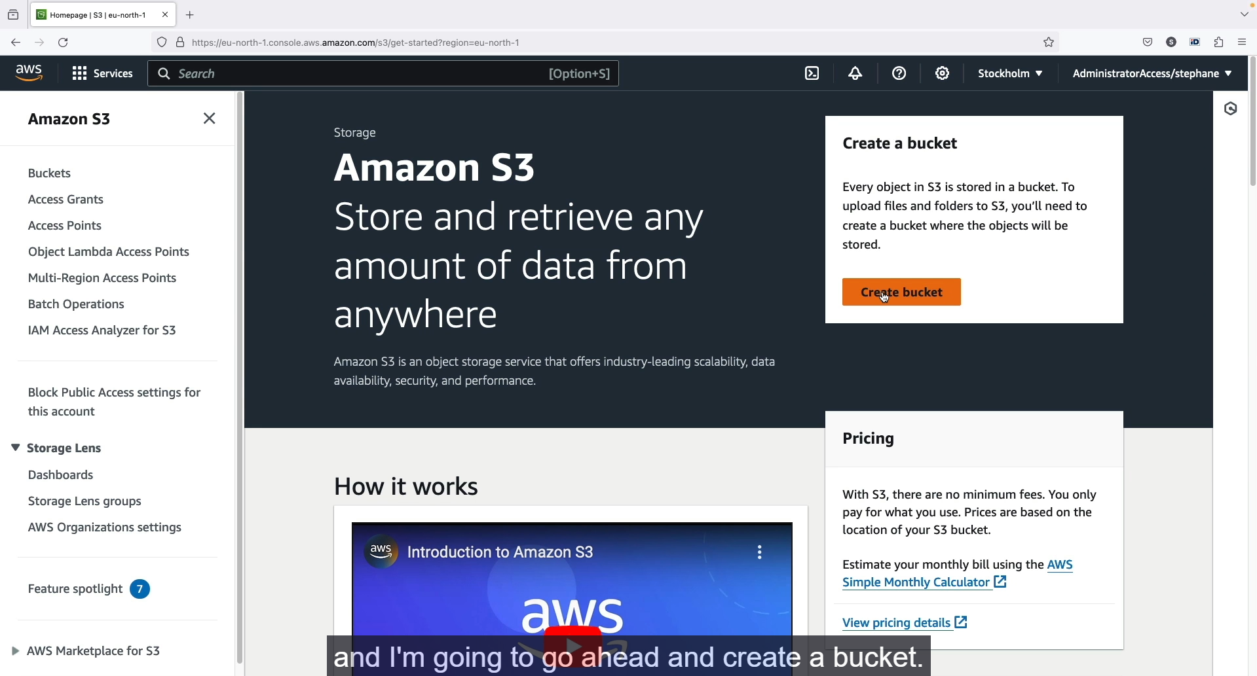

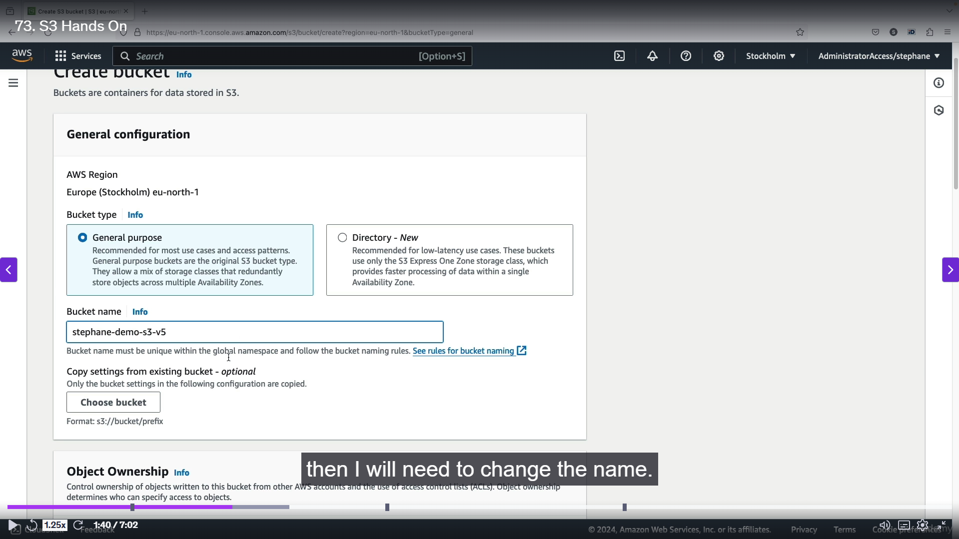

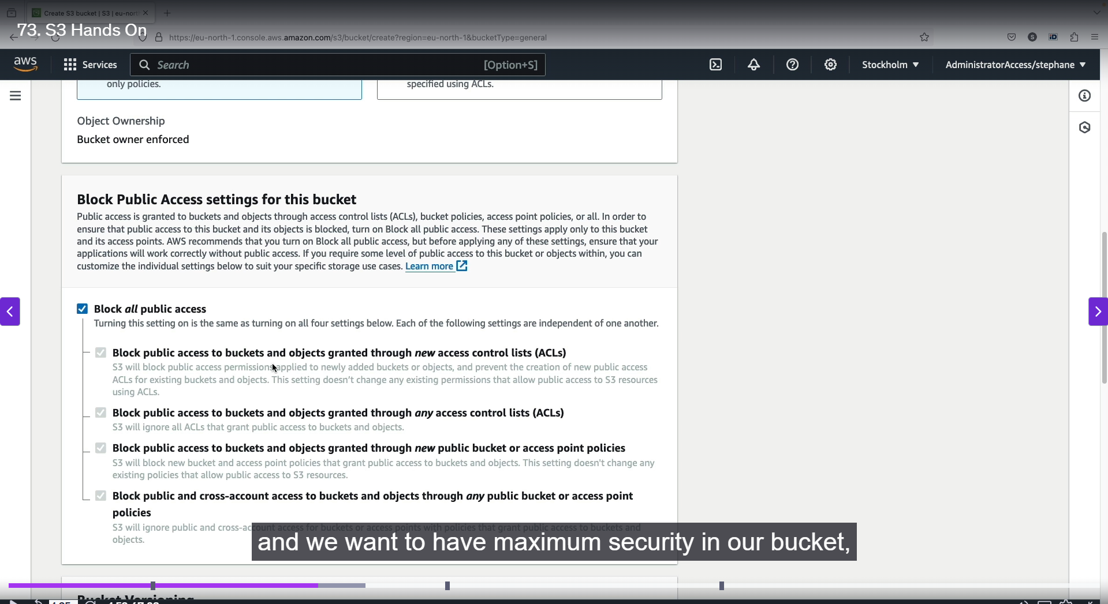

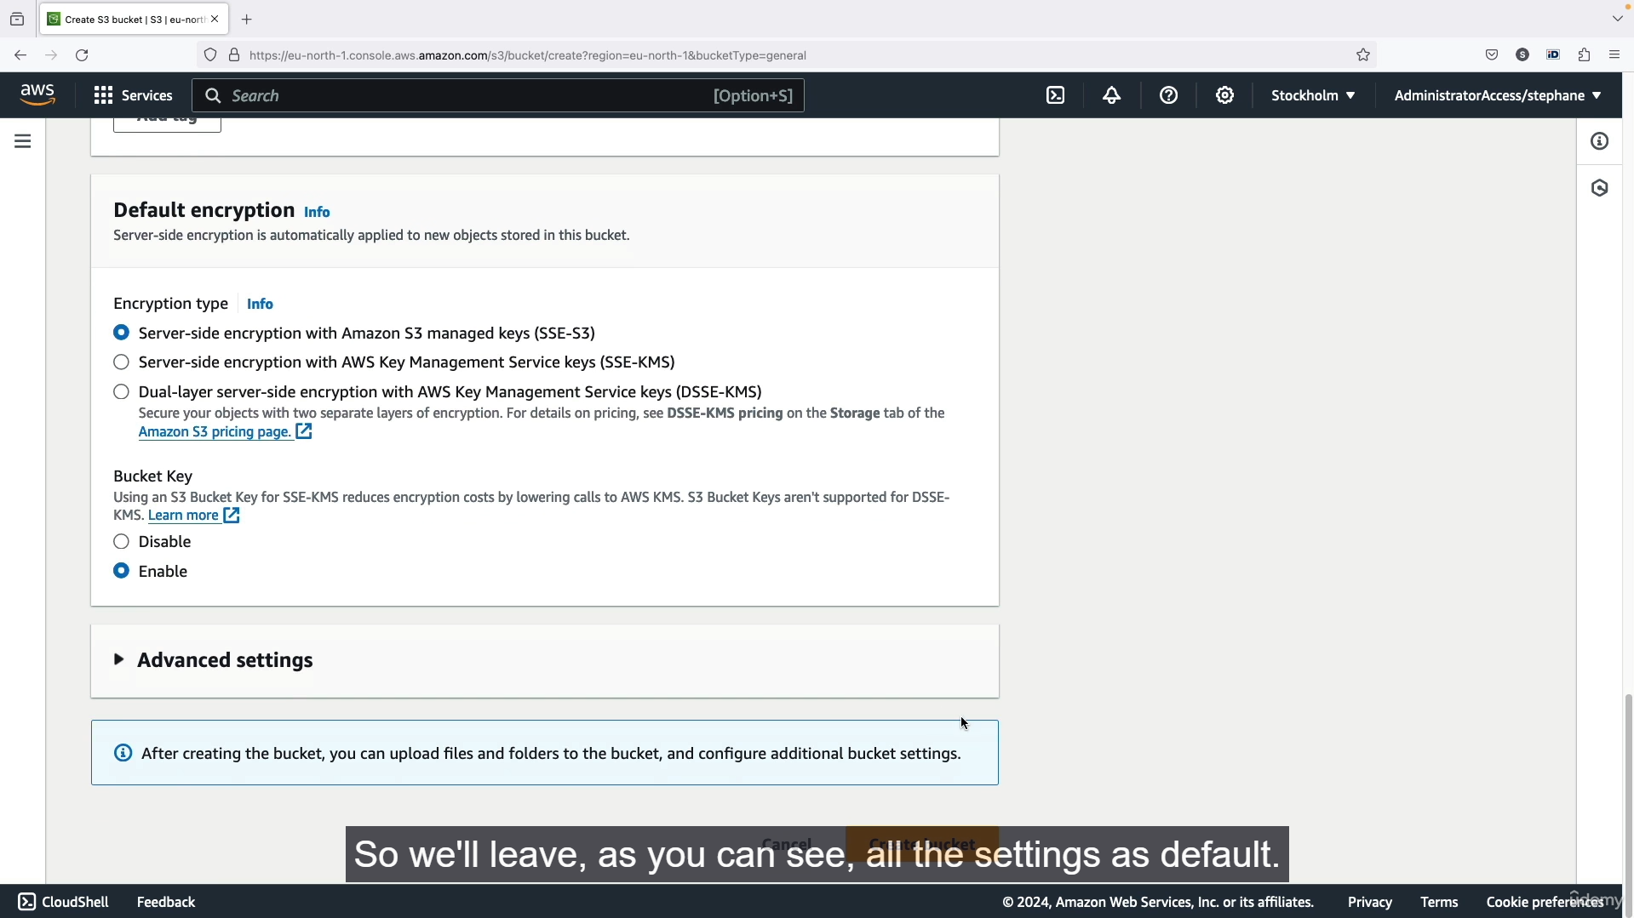

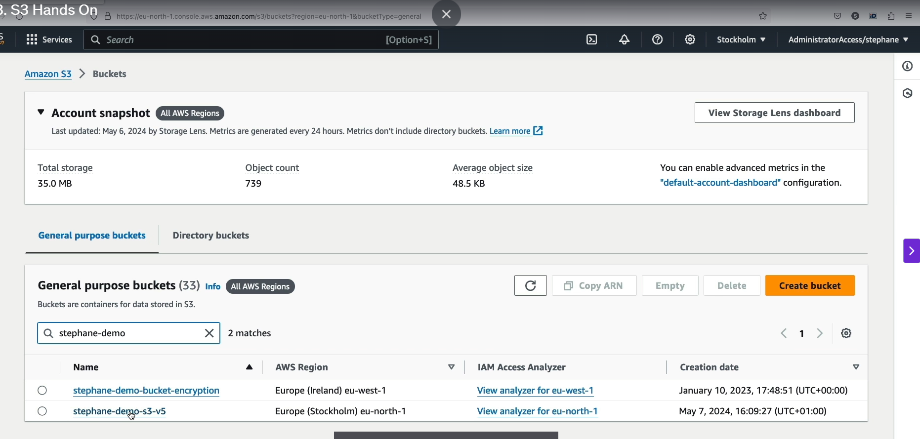

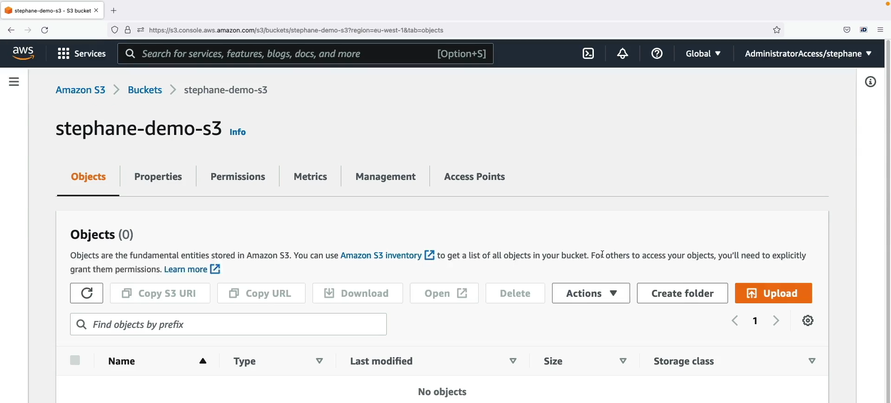

Step1: Search S3 bucket 🡪 create S3 bucket 🡪 Enter into S3 settings 🡪create the s3 bucket.

Step2: Select the general purpose bucket 🡪 enter the S3 bucket name 🡪 leave all the settings as default.

Step3: Finally click create bucket 🡪 bucket created successfully.

Step4: Search the bucket name and you will find the bucket 🡪 click that bucket name to enter into it.



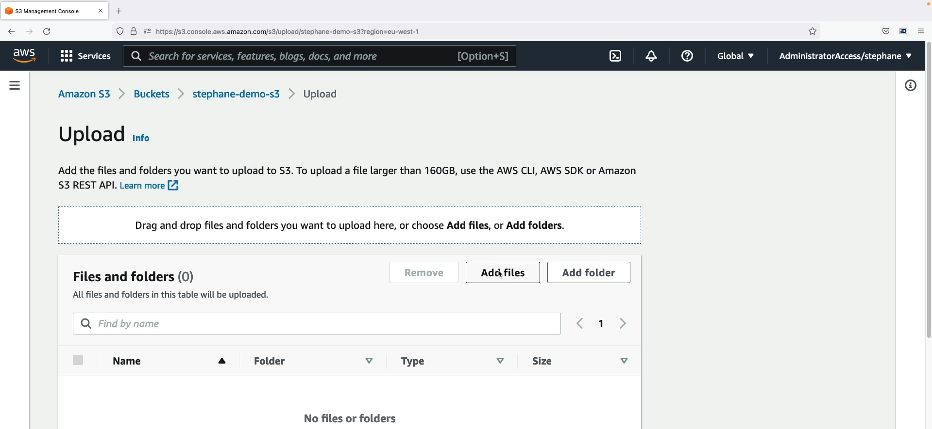

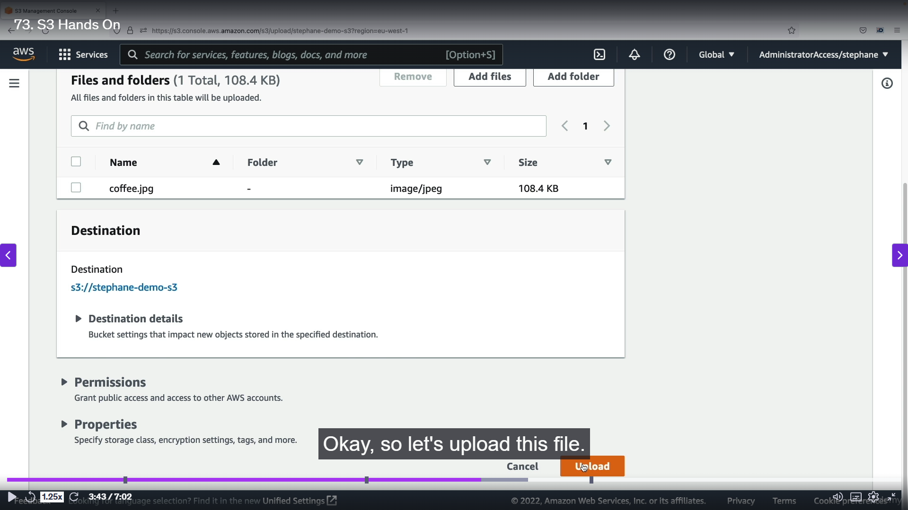

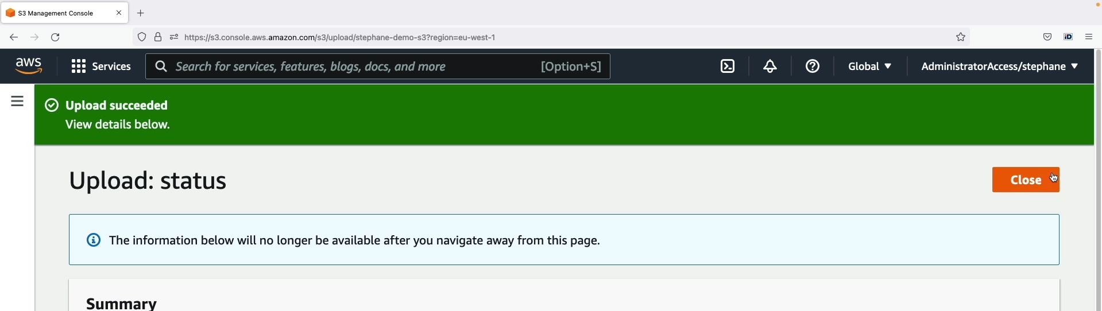

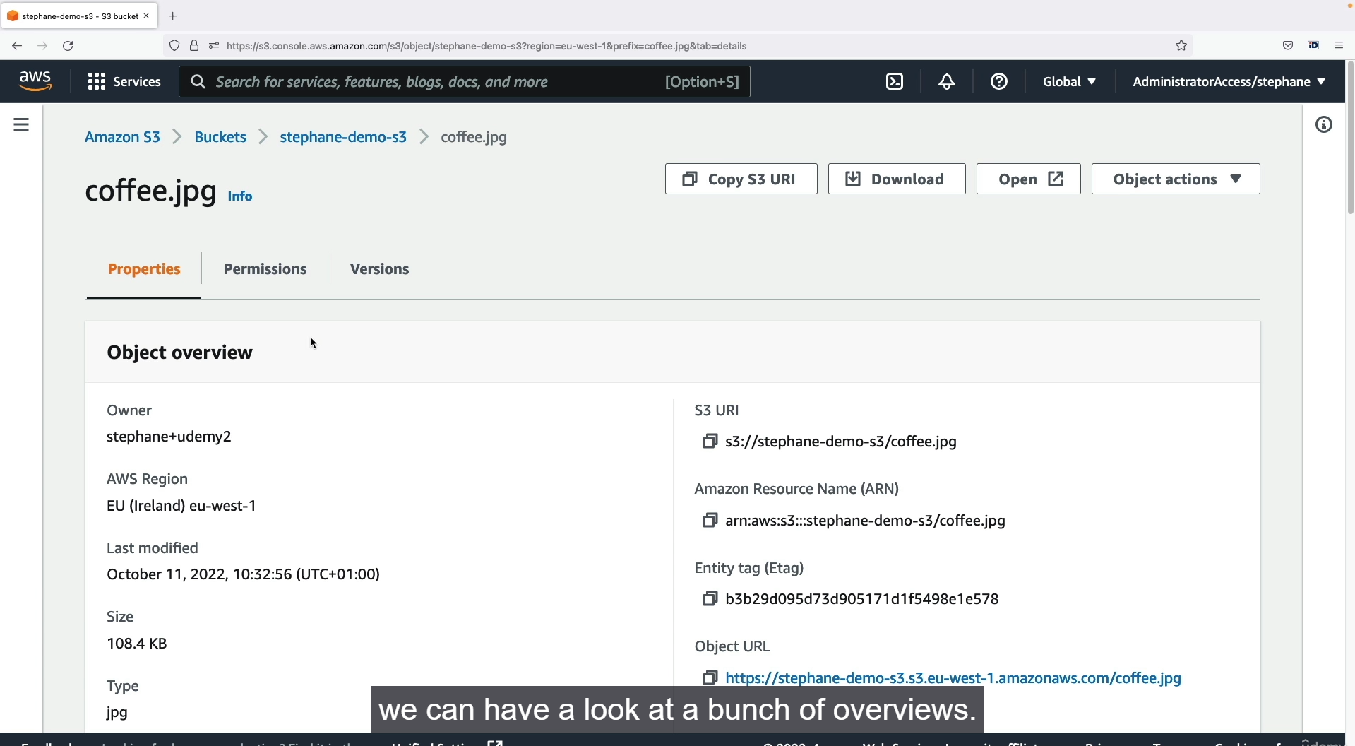

Step1: Now we upload a files in s3 bucket 🡪 click upload 🡪 Add files 🡪 select the files you want to upload in s3 bucket.

Step2: After selecting the files 🡪 Finally click upload to upload 🡪 Files uploaded successfully in S3 bucket.

Step3: Click that file name 🡪 you will find all the details of that file 🡪 size, format, public url, type, owner, AWS region.

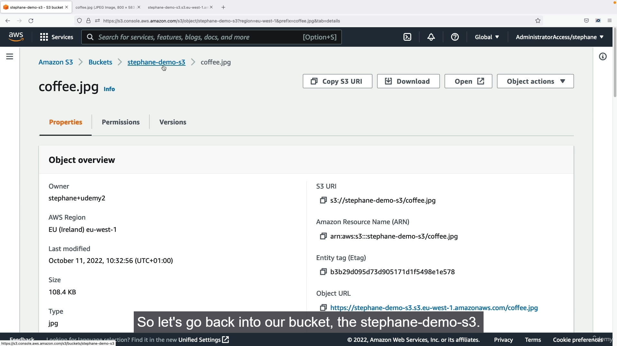

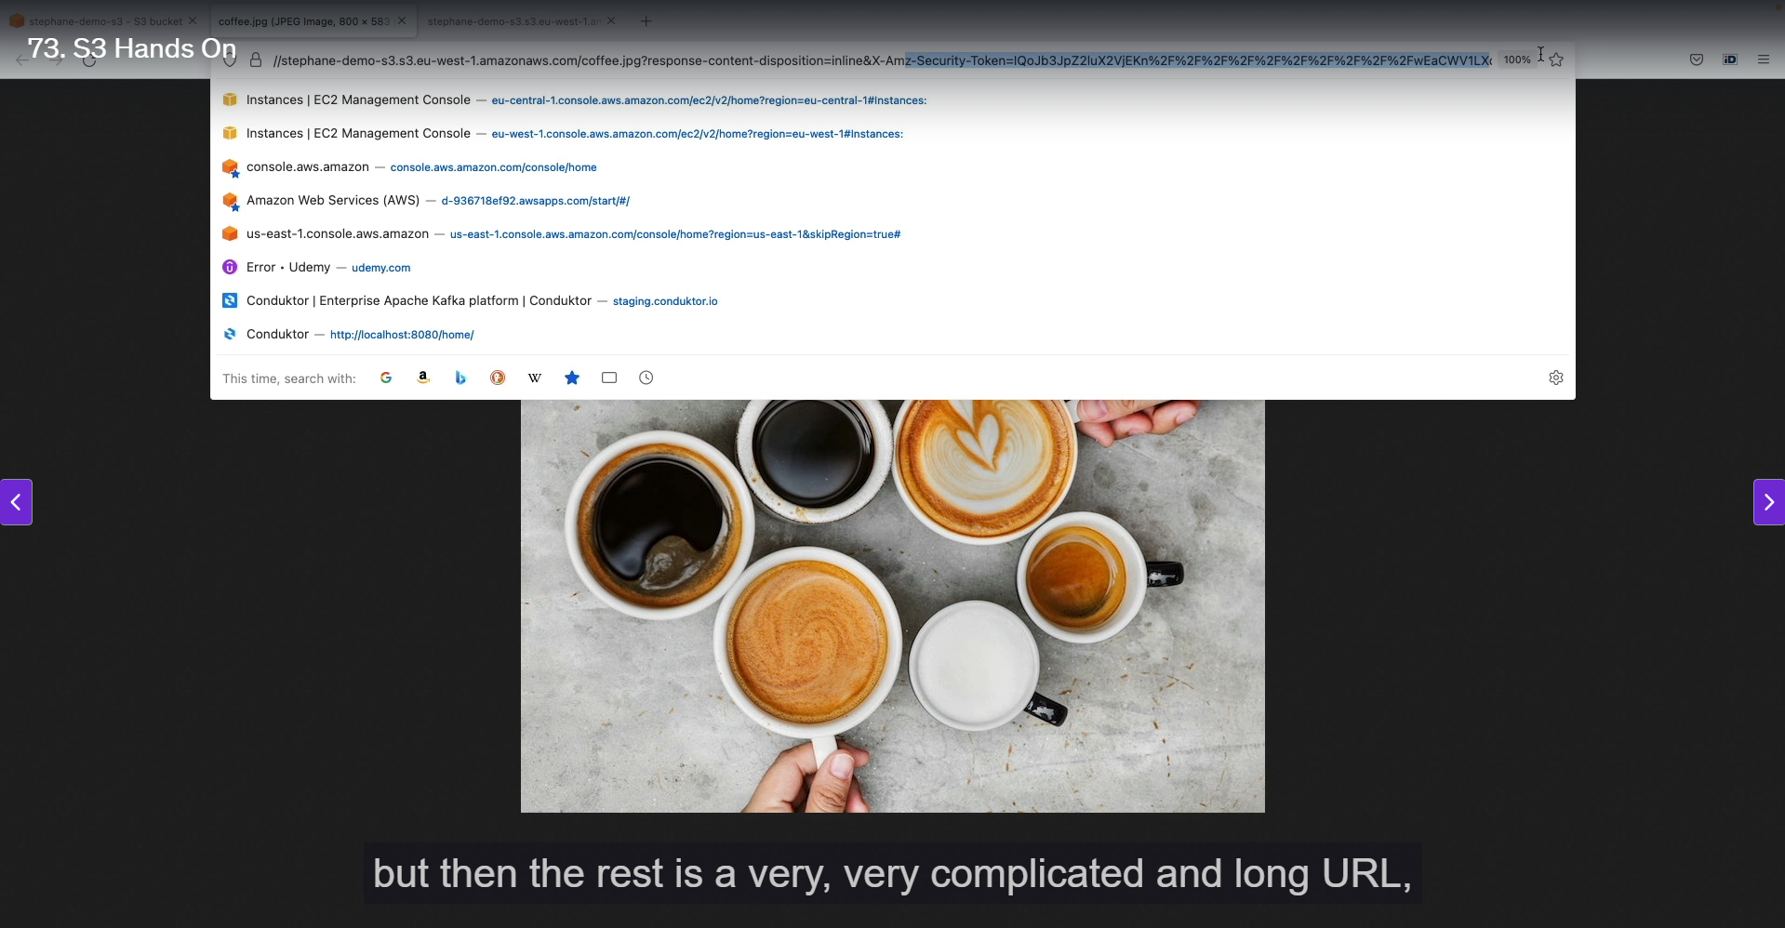

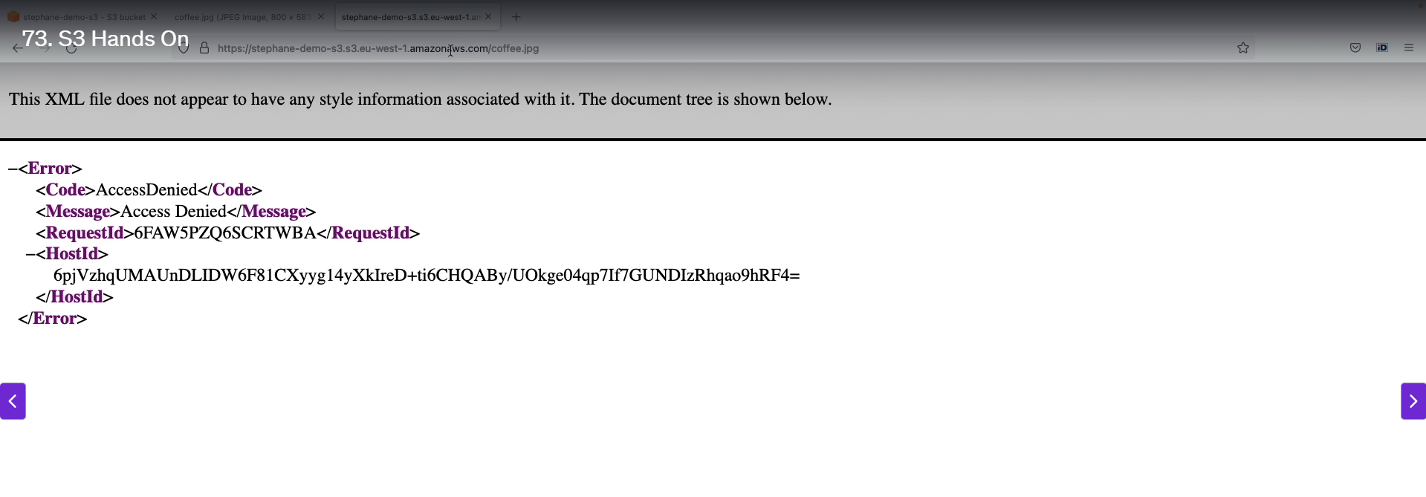

Step1: Now we will open the file which we uploaded 🡪 click the open button in top 🡪 it will directly open the file which we uploaded.

Step2: If we copy the object url and paste in browser means it will not open. Because there will be Access issues in S3 bucket. But the direct open will work because,

**S3 Pre-signed URLs**

A pre-signed URL is a unique URL that provides temporary access to an S3 object. It is a powerful way to grant limited-time access to users without making the object public.

* **Signature:** A pre-signed URL includes a **signature** that verifies the identity and permissions of the user who generated it.
* **Embedded Credentials:** The URL contains the user's encoded security credentials, which S3 uses to authenticate the request.
* **Temporary Access:** Because it's tied to specific credentials and a signature, the URL is only valid for the user who created it and for a set duration, making it more secure than a public URL.
* **Security:** Unlike a public URL, a pre-signed URL ensures that only authorized users can access the content, even if they don't have AWS credentials. The URL essentially acts as a one-time key, allowing access based on the permissions of the user who created the URL.

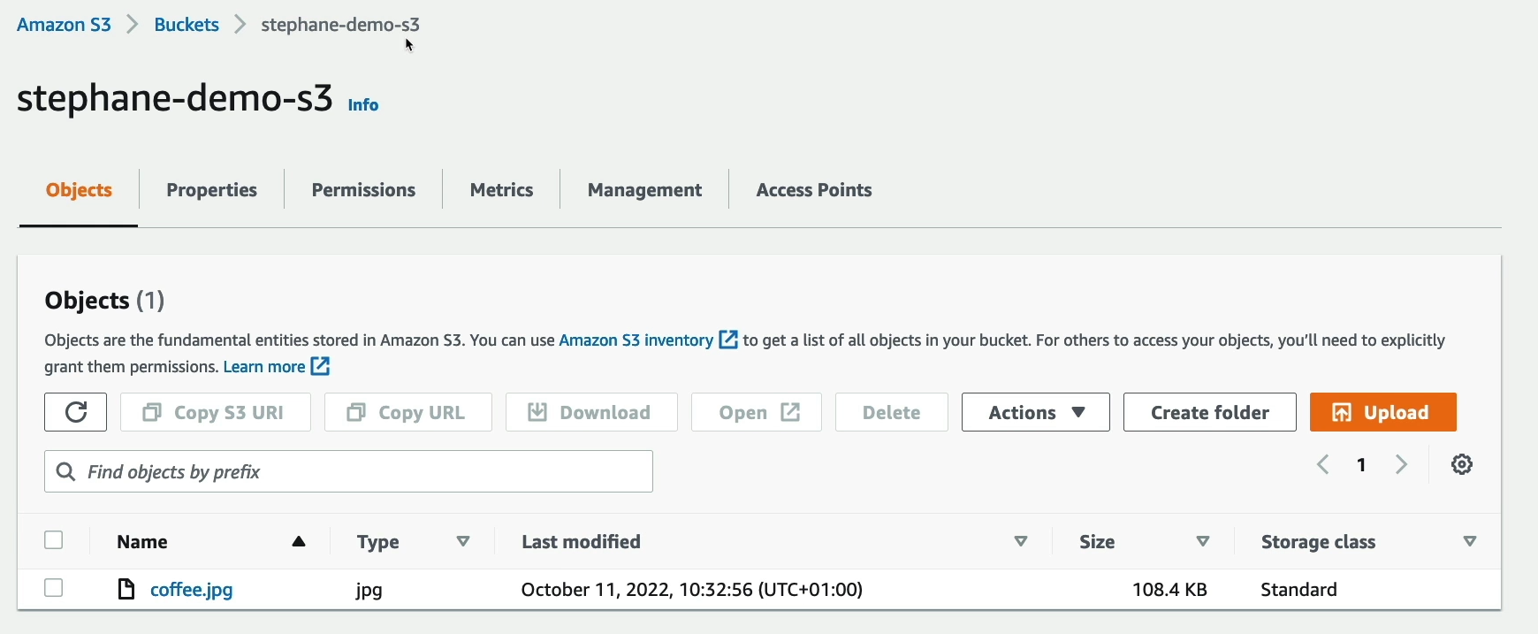

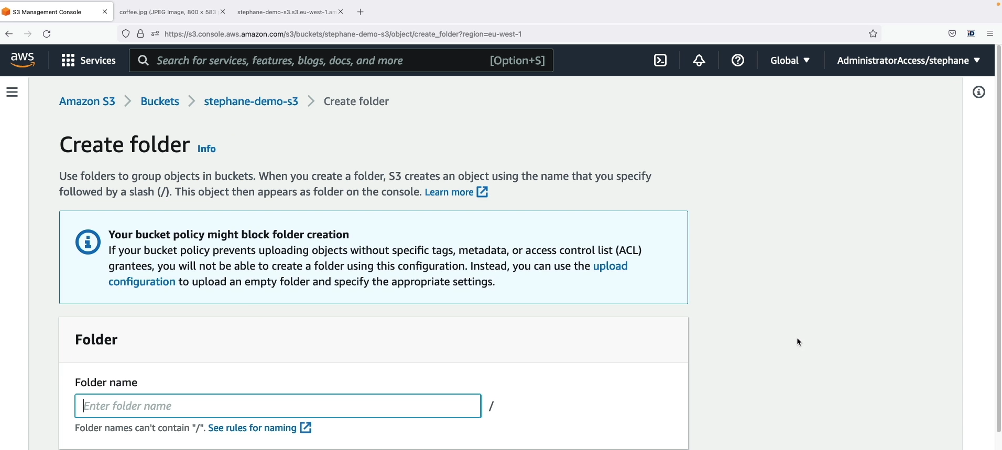

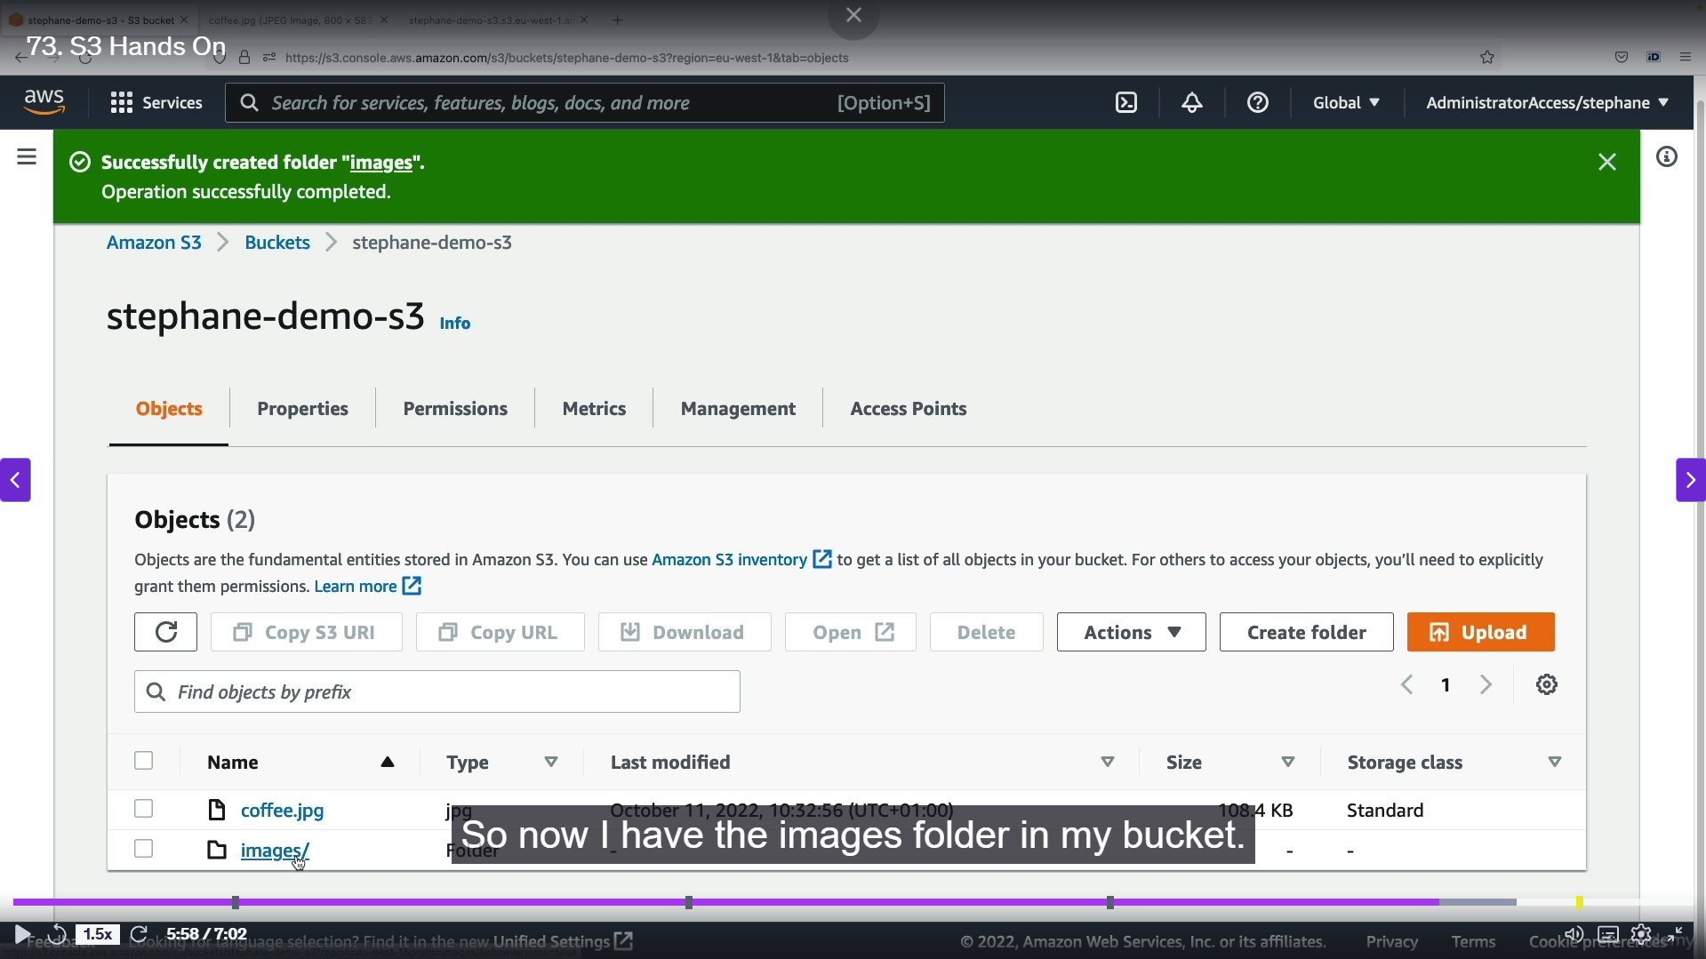

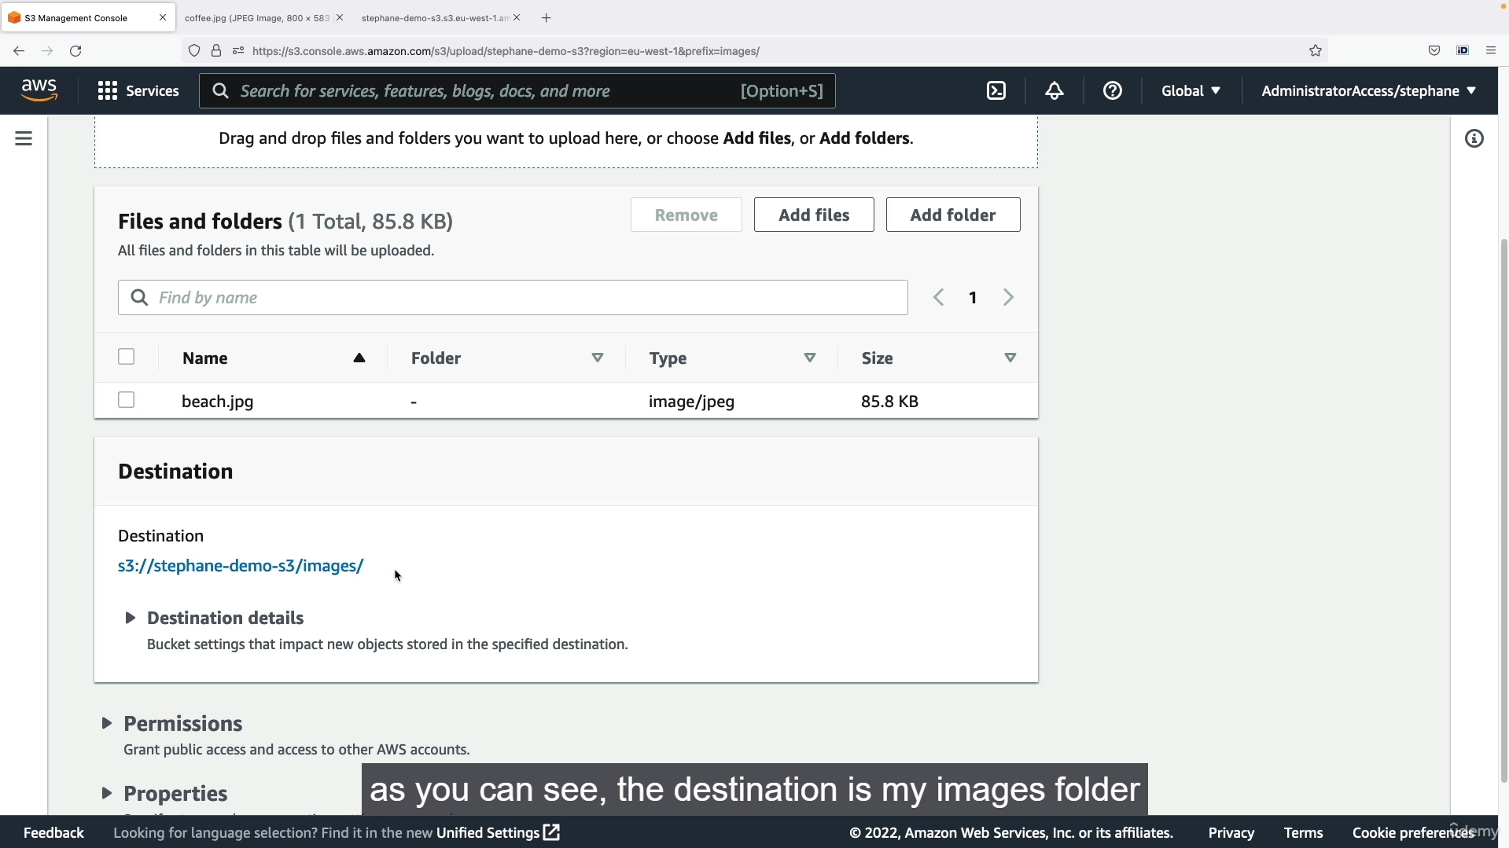

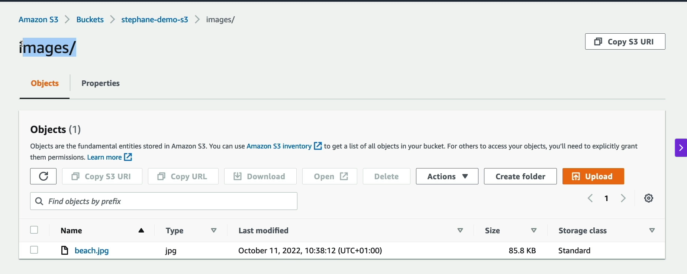

Step1: We can create a folder inside the s3 bucket 🡪 click create folder 🡪 enter the folder name 🡪 click create folder 🡪 Folder created successfully inside S3 bucket.

Step2: Upload files inside that folder 🡪 click that folder 🡪 Add files 🡪 click upload files 🡪 files uploaded successfully inside that folder.

* + 1. **S3 Security: Bucket Policy:**

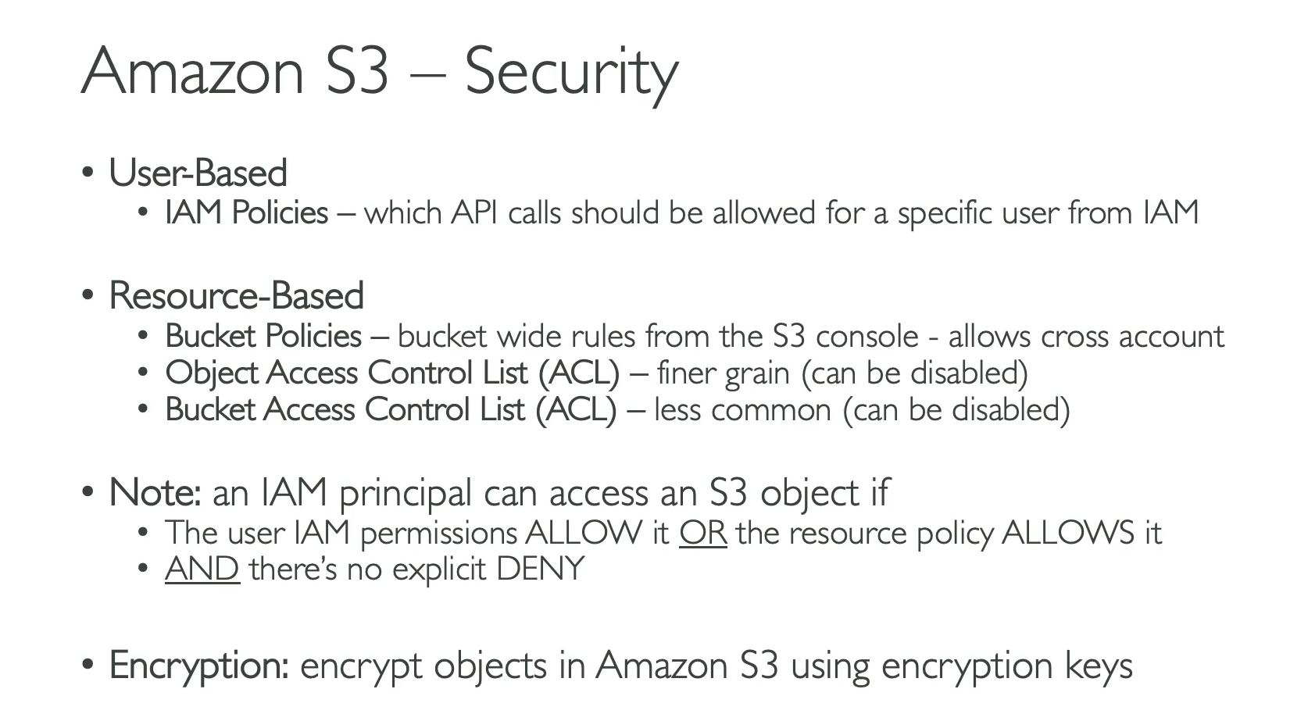

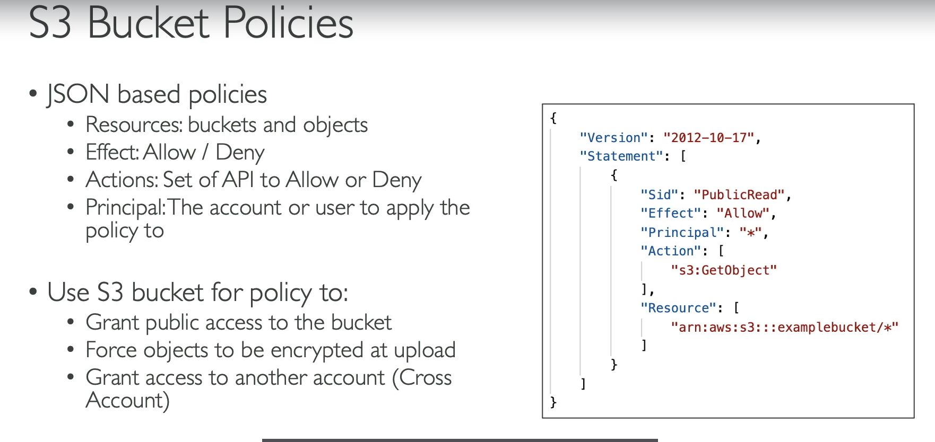

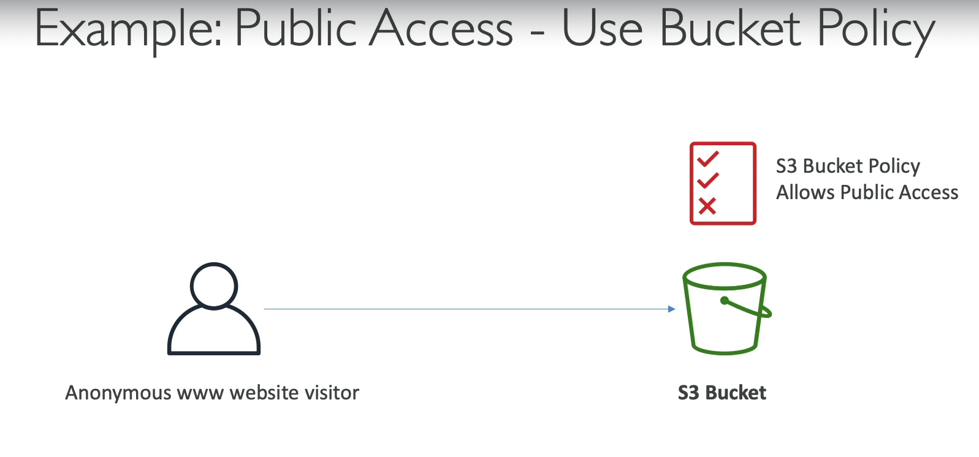

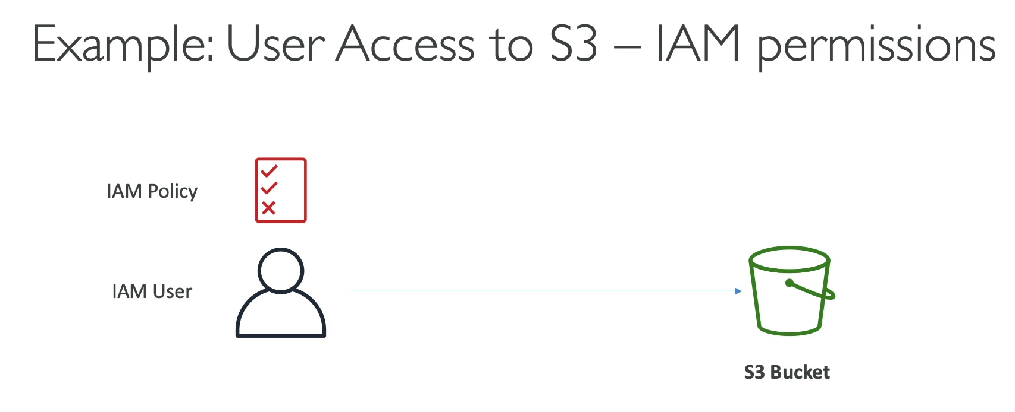

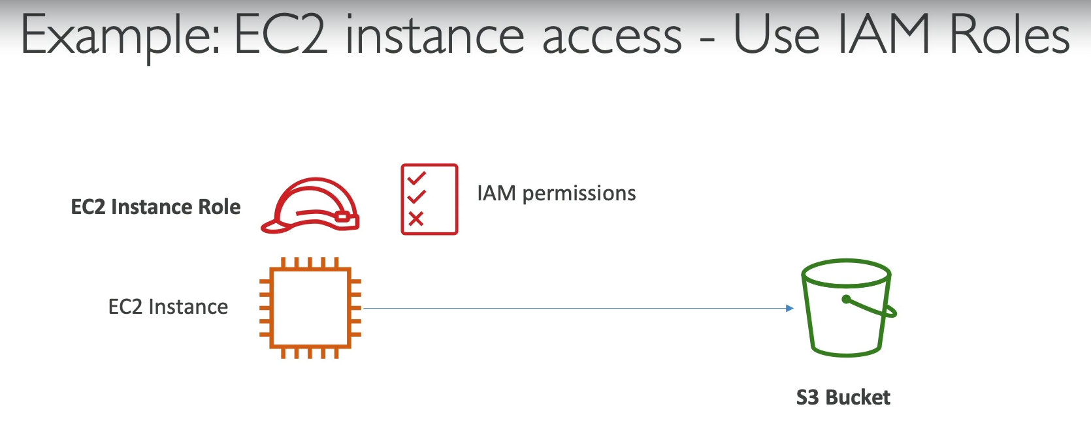

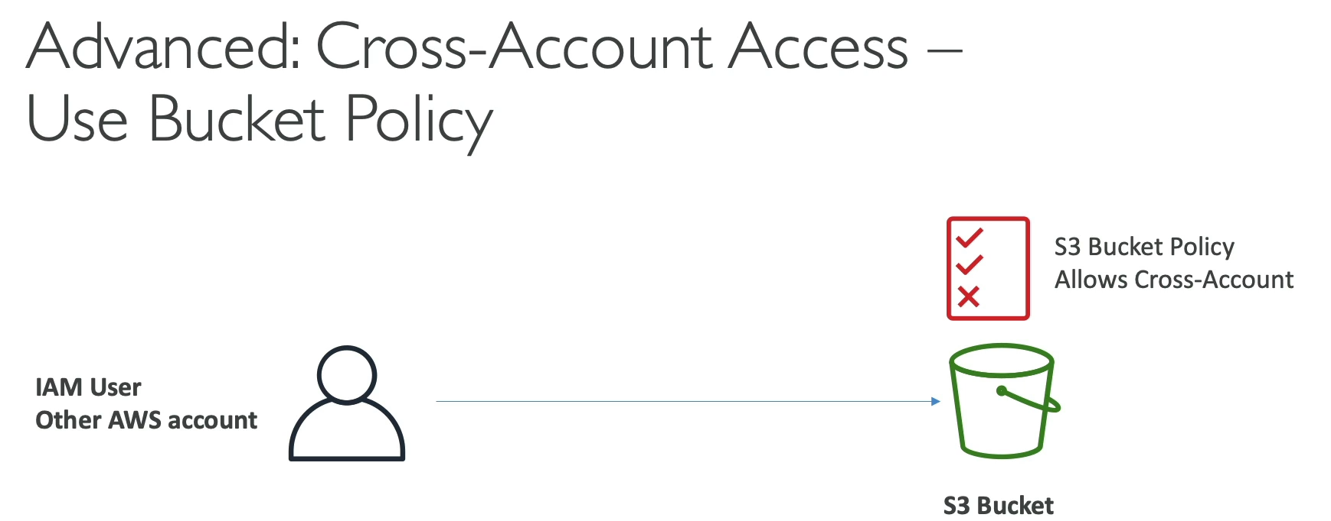

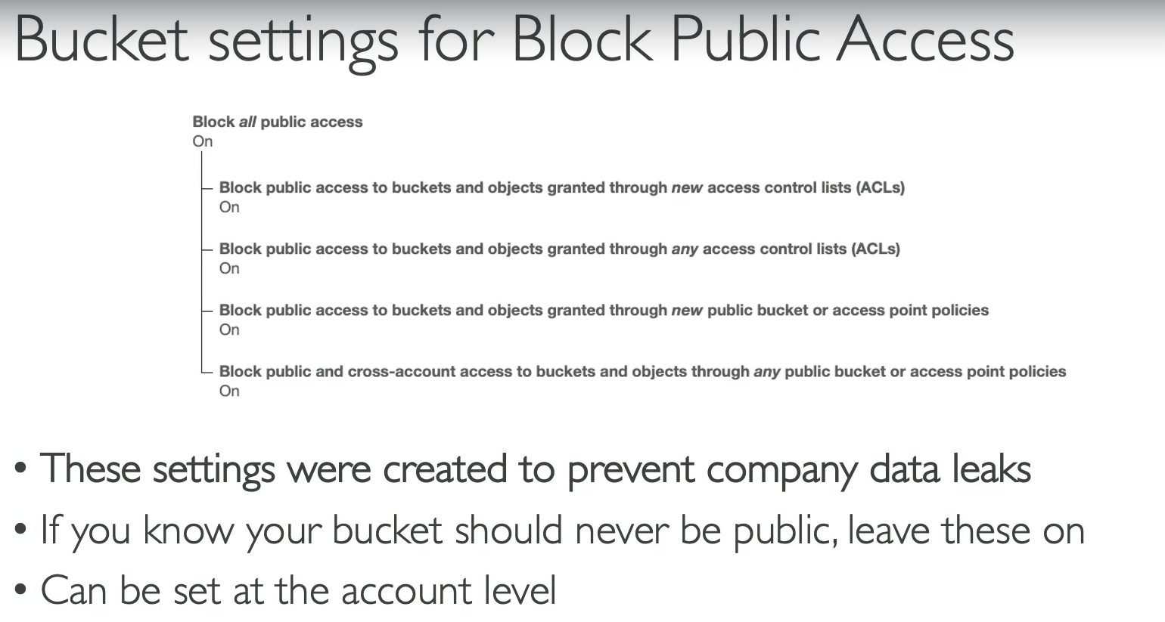

Amazon S3 security is managed through multiple layers, including user-based and resource-based policies, as well as encryption. The most common and flexible way to control access is with S3 bucket policies.

**User-Based Security**

* **IAM Policies:** These are policies attached to individual IAM users or roles. They define which S3 API calls (e.g., GetObject, PutObject) the user or role is allowed to make. This is the primary method for controlling access from within your own AWS account.
* **IAM Roles for EC2:** When an EC2 instance needs to access an S3 bucket, it is best practice to assign an **IAM Role** to the instance. This role has an IAM policy that grants the necessary S3 permissions.

<br>

**Resource-Based Security**

* **S3 Bucket Policies:** This is a JSON-based policy attached directly to the S3 bucket itself. It's a powerful tool for defining **bucket-wide rules**. You can use them to:
  + Grant public access to a bucket (e.g., for a static website).
  + Enforce that all uploaded objects must be encrypted.
  + Grant **cross-account access**, allowing a user from a different AWS account to access your bucket.
  + Bucket policies define **who** (Principal), **what actions** (Action), and on **what resources** (Resource) are allowed or denied (Effect).
* **Access Control Lists (ACLs):** These are an older, more granular security method that can be applied at the bucket or object level. While they still exist, **bucket policies are the recommended approach** for most use cases because they are more comprehensive and easier to manage. ACLs can also be disabled.

<br>

**Other Security Mechanisms**

* **Encryption:** You can encrypt objects stored in S3 using encryption keys. This ensures that the data is protected both in transit and at rest.
* **Block Public Access:** This is a crucial security feature that acts as a safety net. It can be set at the account or bucket level. If this setting is enabled, it will **override any bucket policies** that attempt to make the bucket public, preventing accidental data leaks. It's recommended to keep this enabled unless you specifically need a public bucket.

**Summary of Access Scenarios**

An IAM user or role can access an S3 object if either their **IAM policy allows it** OR the **S3 bucket policy allows it**, and there is **no explicit deny** in either policy. This creates a flexible but potentially complex system where permissions can be granted from either the "user" or the "resource" side.

* + 1. **S3 Security: Bucket Policy Hands On:**

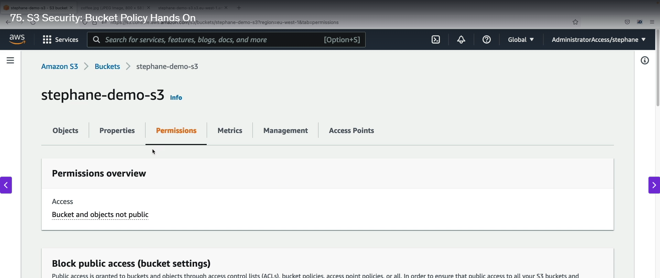

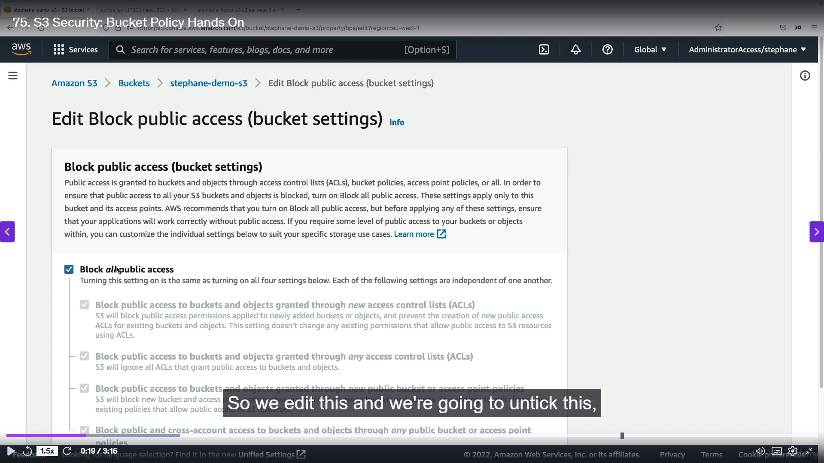

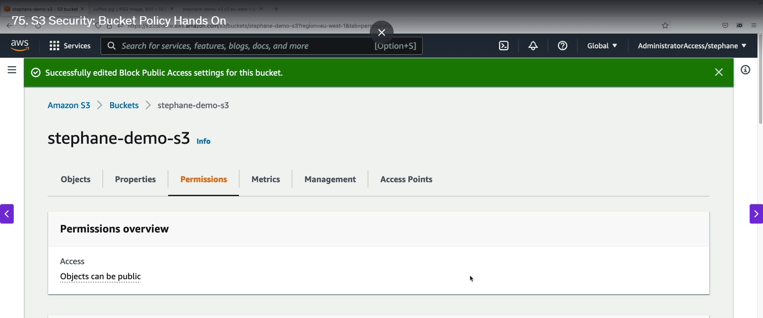

Step1: Enter into bucket settings 🡪Permissions 🡪 BY default it will block all the public access 🡪 make it disabled 🡪 click save.

Step2: The permission were set successfully.

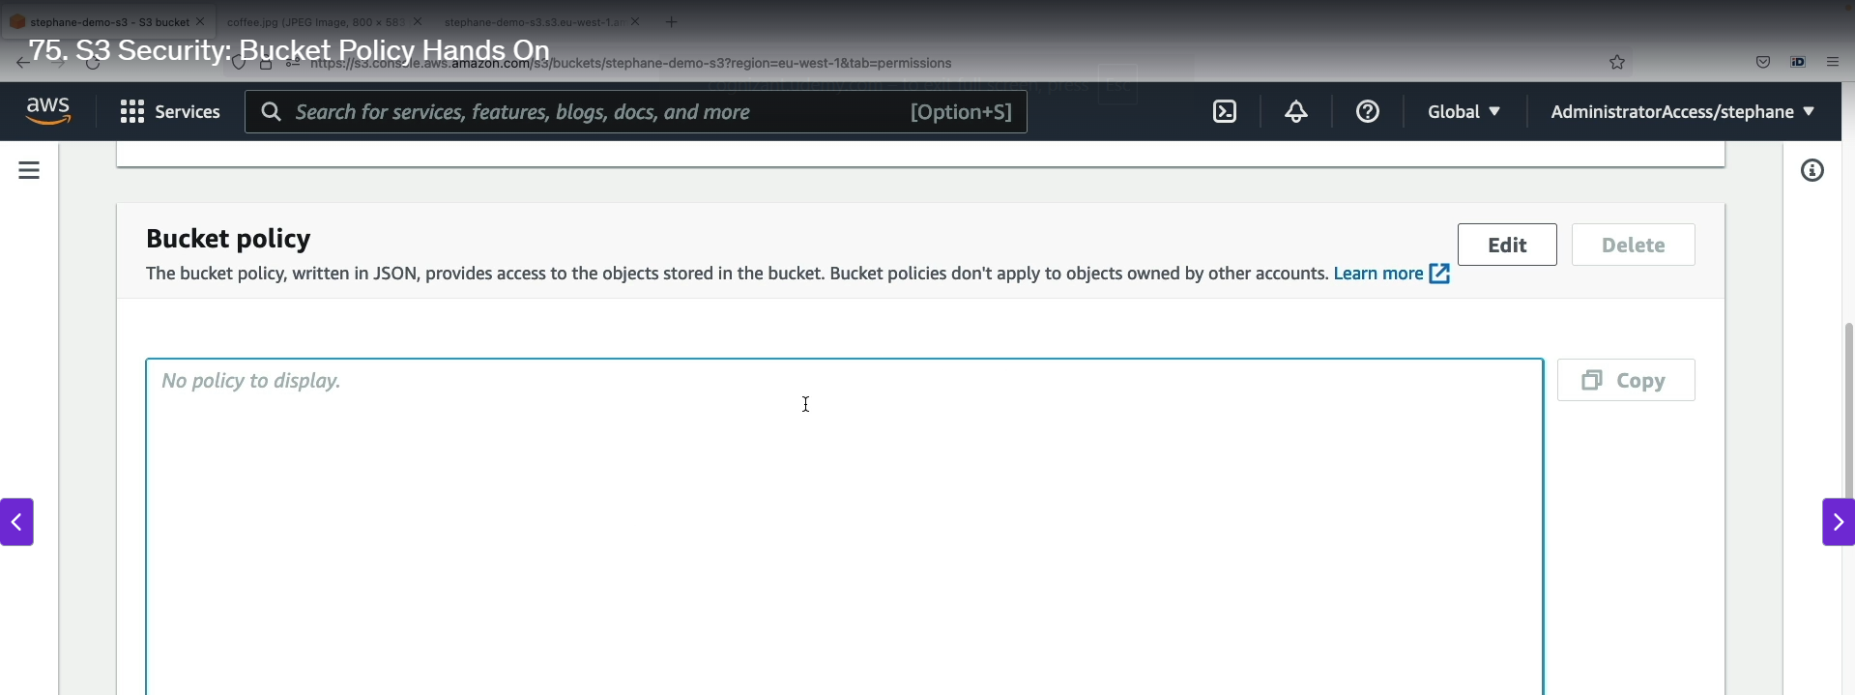

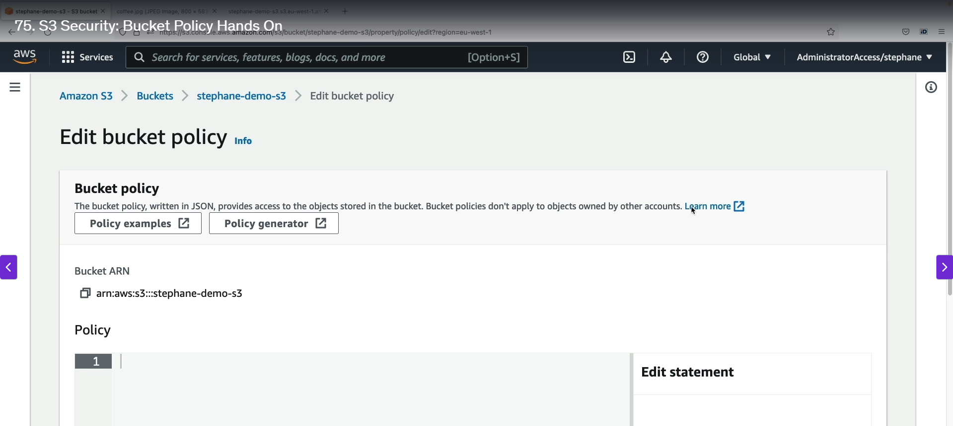

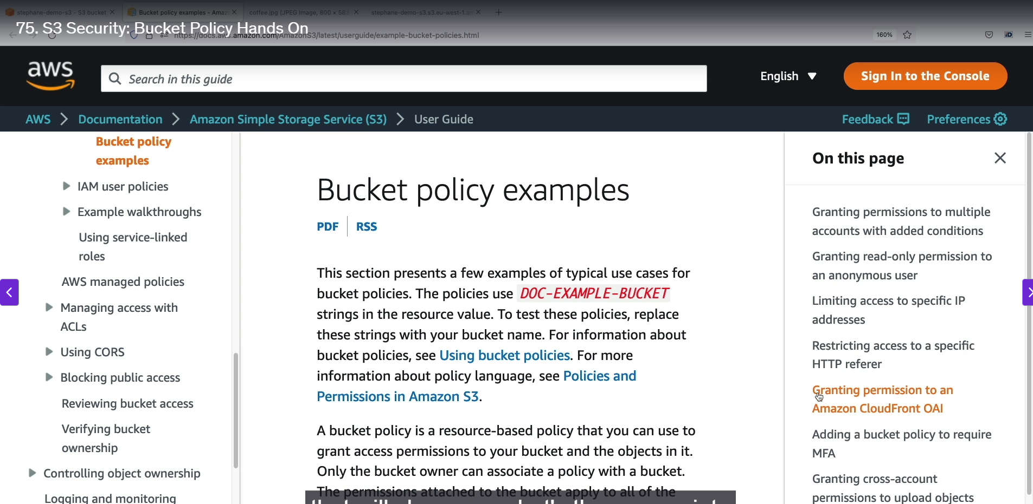

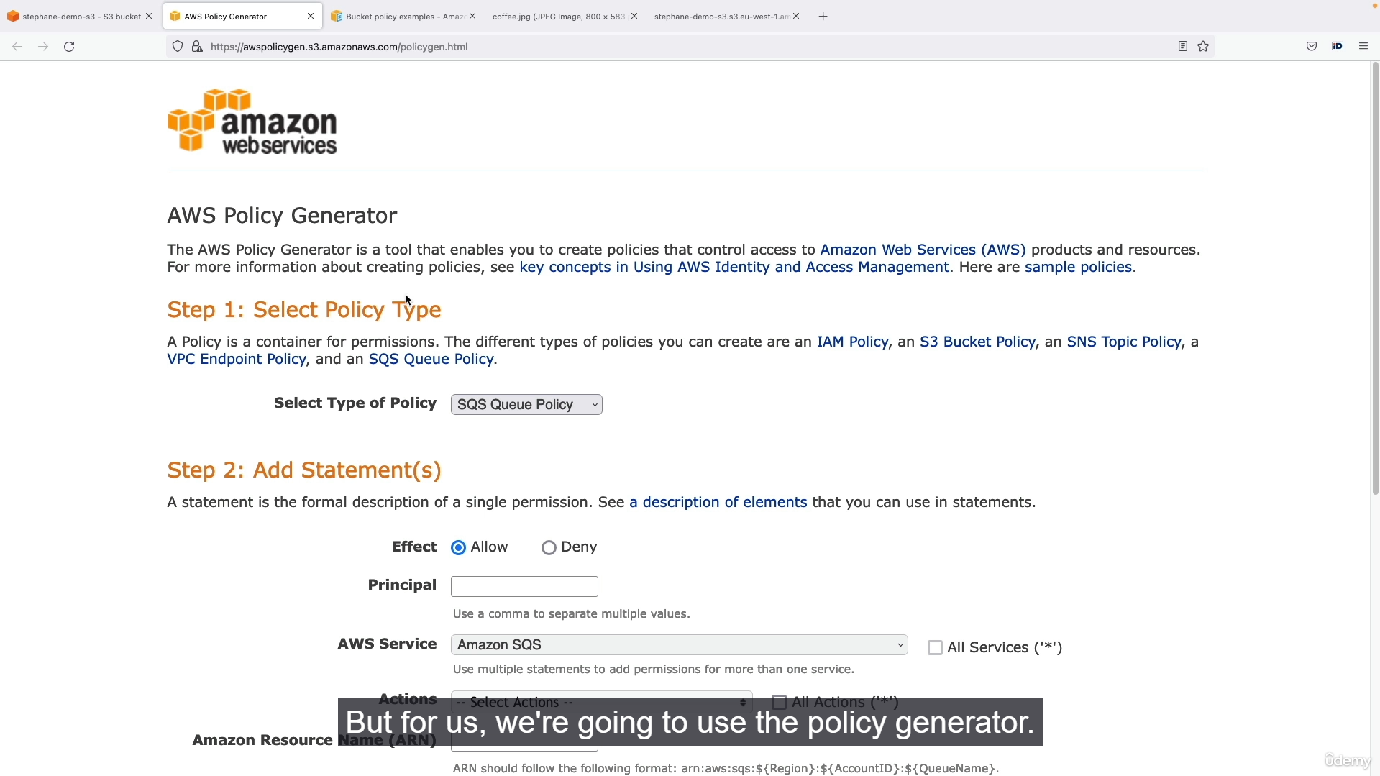

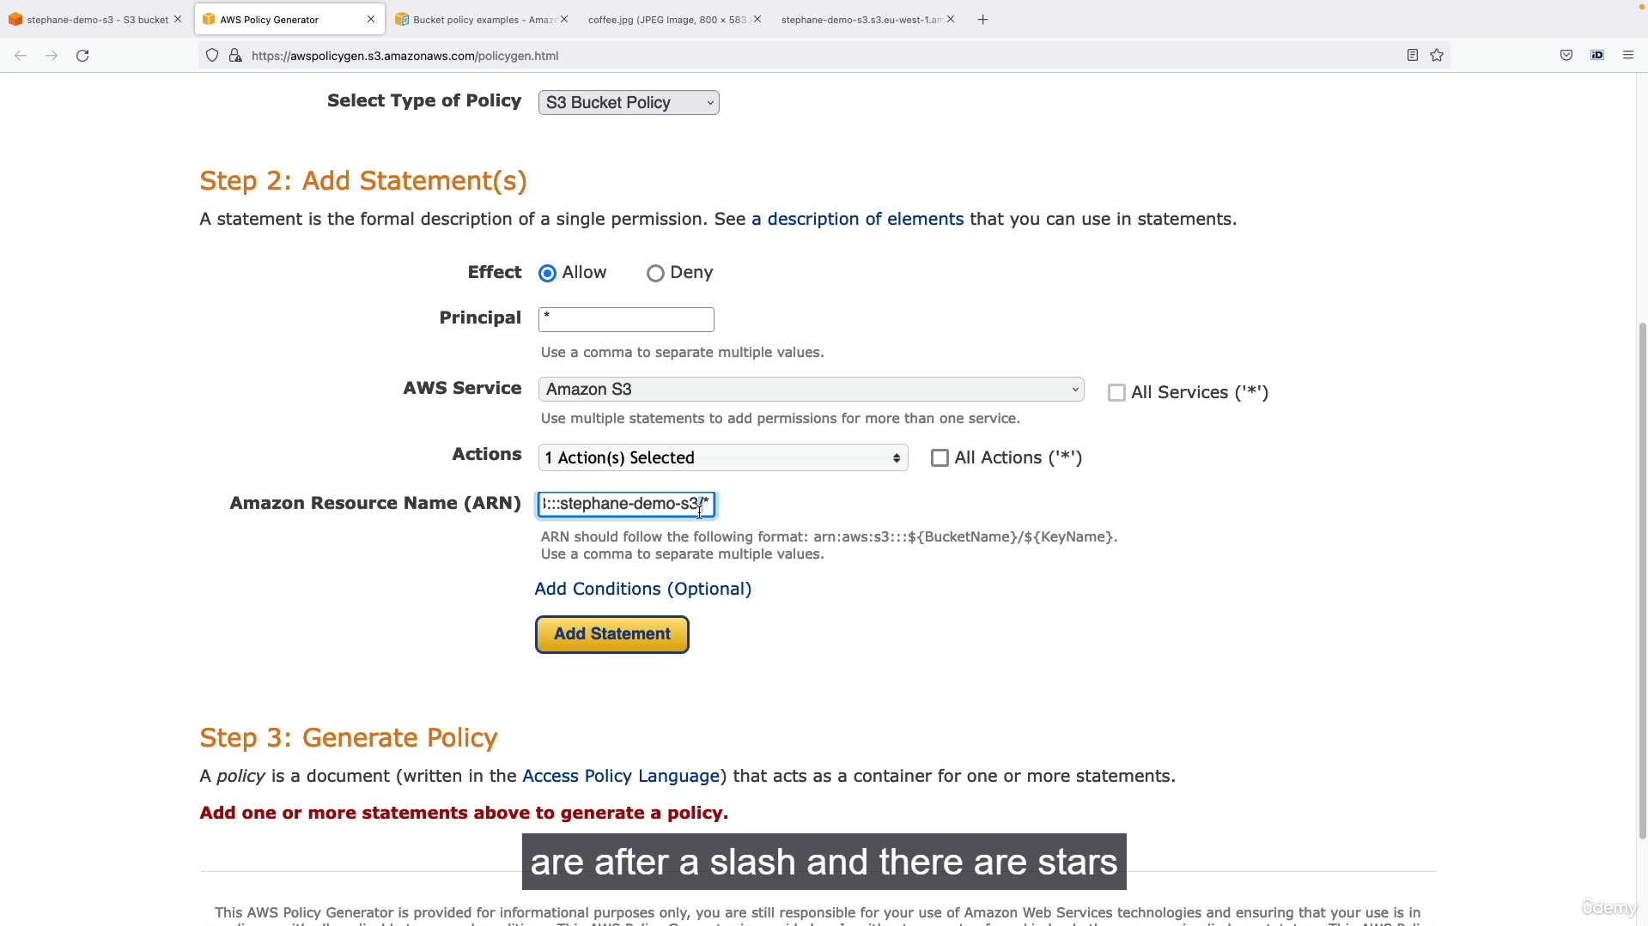

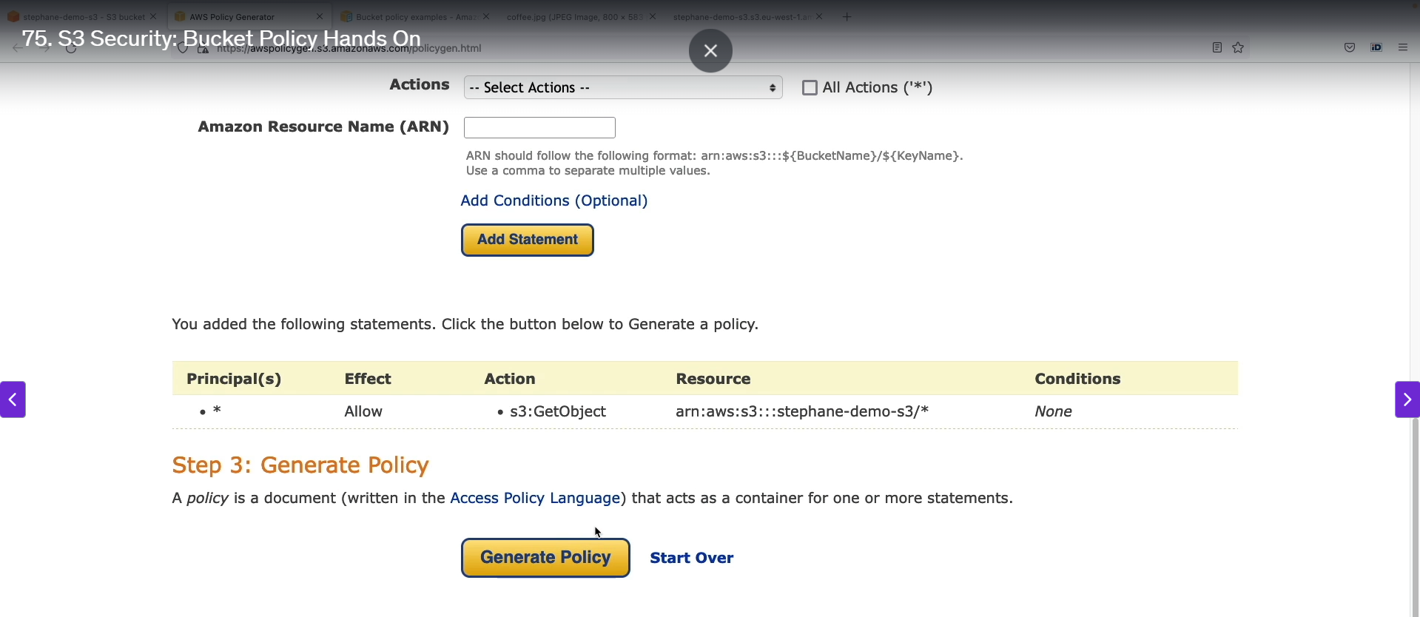

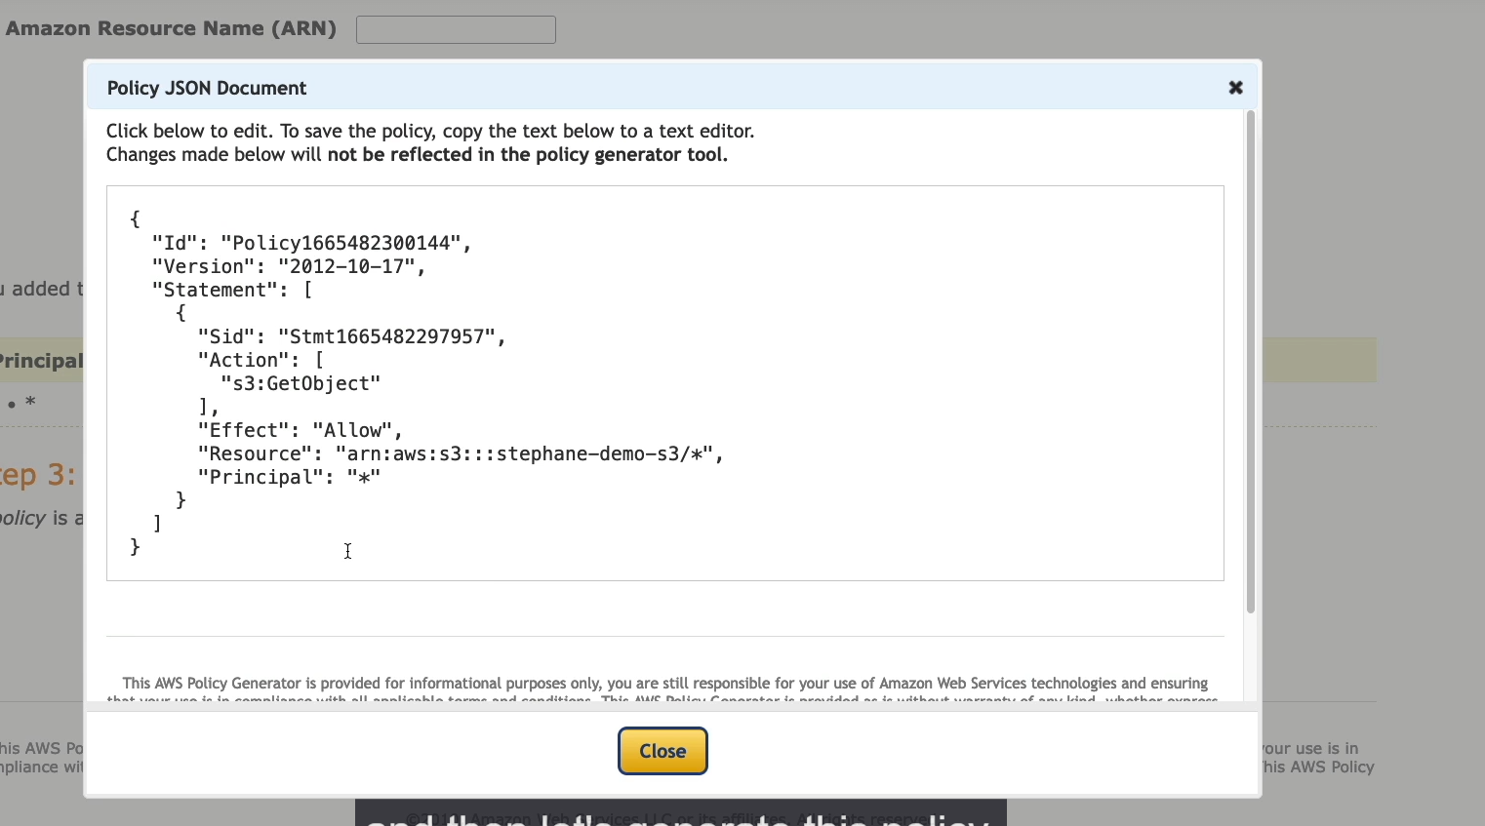

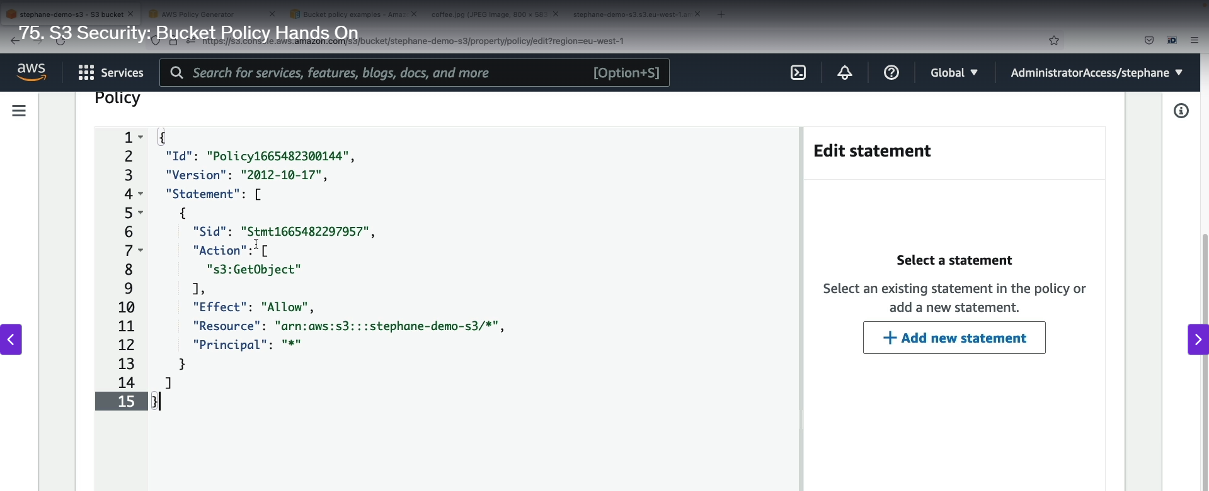

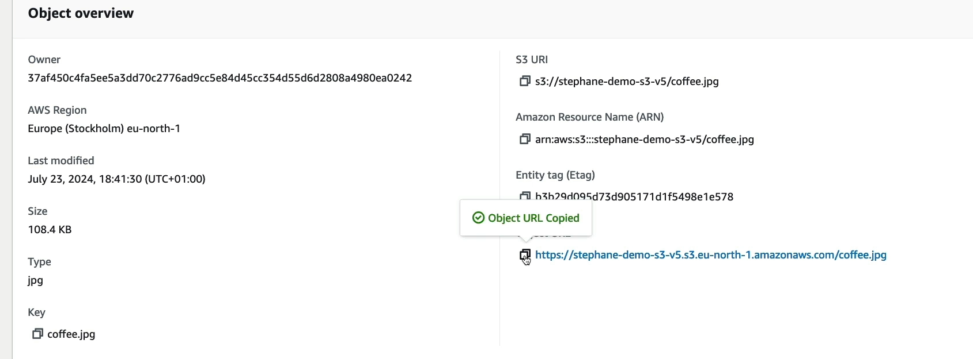

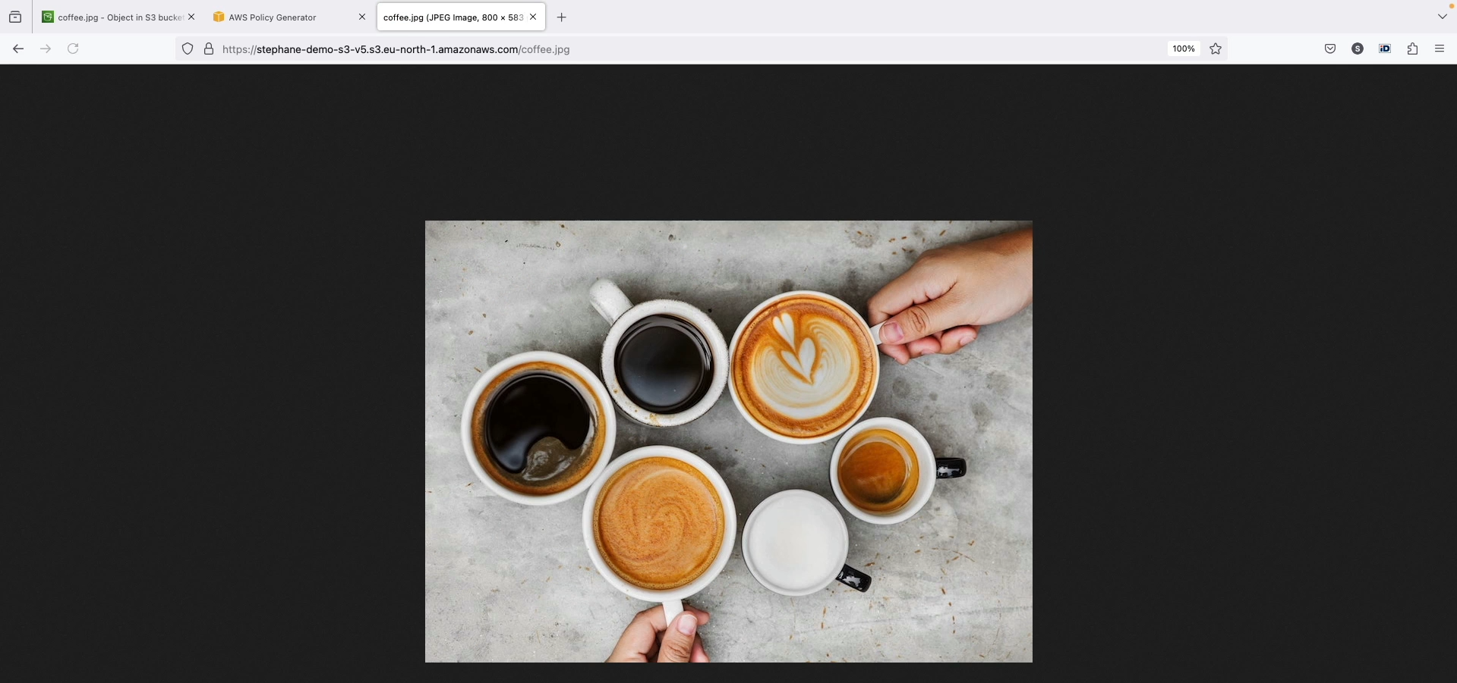

Step1: Now we want to create the bucket policy 🡪 It will be in JSON format.

Step2: Select edit option in bucket policy 🡪 there will be two inbuilt options 🡪 policy examples and policy generator.

Step3: Policy Examples 🡪 It will went to some inbuilt examples policy from which we can copy and paste.

Step4: Policy generator 🡪 It will generate policy in JSON format 🡪 for that we want to select our requirements.

Step5: Enter into policy generator settings 🡪 select the policy type (S3 bucket policy) 🡪 effect “allow” 🡪 principle * (Because everyone want to access) 🡪 AWS service “S3 bucket” 🡪 Select the action (* for all actions) 🡪 Copy the bucket ARN from bucket policy settings 🡪 paste there and add /* in end 🡪 click add statement 🡪 click generate policy.

Step6: The policy generate in JSON format 🡪 Copy that policy 🡪 paste in bucket policy area 🡪 save.

Step7: Now copy the object url 🡪 paste in browser 🡪 we are able to access that object which is blocked before.